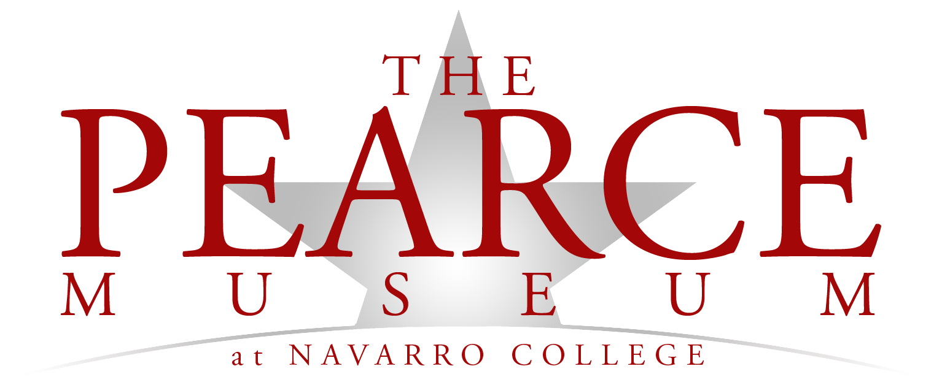

…to connect with the past by engaging today’s visitor through personal perspectives of the Civil War and the American West.
(Corsicana, Texas) The Pearce Museum and officials from Navarro College are following guidelines set forth by the Centers for Disease Control (CDC) and the Texas Department of State Health Services (DSHS) to prevent the spread of Covid-19. With Governor’s Abbotts recent announcement that museums may open beginning May 1 (Open Texas), the staff at the Pearce has been working diligently to make sure we provide a safe environment for staff, volunteers, and visitors. The following guidelines will be updated as needed.
Our hours of operations are Monday-Friday: 10am-4pm; closed Saturday, Sunday and Select Holidays. These hours are subject to change.
All visitors are required to fill out the “Navarro College Pre-Screening Questionnaire” prior to visiting the Pearce Museum, Planetarium etc. To fill out the form, please click on the following link: https://form.jotform.com/201756514356052
The staff are required to symptom check and have their temperature checked before they enter the museum.
- Any visitor entering the museum MUST symptom check before entering. If you are feeling sick or have any of the following symptoms listed below, stay home!
- Cough
- Sore throat
- Shortness of breath
- Chills
- Muscle pain
- Headache
- Loss of taste or smell
- Diarrhea
- Feeling feverish or measured temperature greater than or equal to 100.0 degrees Fahrenheit
- Known close contact with a person who is lab confirmed to have Covid-19
Employees, contractors, or volunteers with new or worsening signs or symptoms listed above to return to work until:
- In the case of an employee, contractor, or volunteer who was diagnosed with COVID-19, the individual may return to work when all three of the following criteria are met: at least 3 days (72 hours) have passed since recovery (resolution of fever without the use of fever-reducing medications); and the individual has improvement in symptoms (e.g., cough, shortness of breath); and at least 10 days have passed since symptoms first appeared; or
- In the case of an employee, contractor, or volunteer who has symptoms that could be COVID-19 and does not get evaluated by a medical professional or tested for COVID-19, the individual is assumed to have COVID-19, and the individual may not return to work until the individual has completed the same three-step criteria listed above; or
- If the employee, contractor, or volunteer has symptoms that could be COVID-19 and wants to return to work before completing the above self-isolation period, the individual must obtain a medical professional’s note clearing the individual for return based on an alternative diagnosis.
Do not allow an employee, contractor, or volunteer with known close contact to a person who is lab-confirmed to have COVID-19 to return to work until the end of the 14-day self-quarantine
Face Masks, Social Distancing, Cleaning & Signage
- Face masks/coverings are required in order to visit the Museum. As part of Navarro College, we will continue to follow previous guidelines set by college officials. Masks may be provided, if supplies allow.
- Social distancing will be utilized. Maintain at least 6 feet separation from individuals not in the safe household or visiting the museum together.
- Staff are required to wear masks at all times.
- Staff and volunteers will be properly trained on cleaning and disinfecting commonly used areas.
- Wash or sanitize hands before entering the museum (Cook Center), and after interaction with employees, visitors, or after handling items.
- Staff members will wipe down door handles, counters, benches, restrooms etc., multiple times throughout the day.
- Signage about social distancing has been placed throughout the museum.
Gift Shop
- Temperatures may be taken in Gift Shop.
- The Gift Shop will be open, if possible, please use a credit card to prevent handling of money; cardholder will be disinfected in between each transaction.
- Plexi glass has been installed in the Gift Shop to minimize contact between the staff member and visitors.
Galleries
- The Hunter-Gatherers of the Blackland Prairie Gallery is open! After every visitor, the gallery will be wiped down with disinfecting wipes or sprayed with disinfecting spray.
- Pencils will be provided at the beginning of your visit at the Pearce; the pencils will be used to touch frequently touched surfaces i.e., buttons, screens etc.
- If we have more than one family in the museum, we will make every effort to make sure the families are not in the same space at any given time.
- Do not touch any of the displays in the Civil War Gallery or artwork in the Western Art Gallery.
- After each showing of the Pearce Introductory, Civil War Introductory and Medical tent videos, the seats will be sprayed down by the staff.
- We are currently booking groups. For more information call us at 903-875-74737.

Center for Disease Control: https://www.cdc.gov/coronavirus/2019-ncov/need-extra-precautions/index.html
Texas Department of State Health Services: https://www.dshs.texas.gov/
Office of the Texas Governor, Greg Abbott: https://gov.texas.gov
Navarro College: https://www.navarrocollege.edu/covid-19/

